**Small World Networks:**

The small world phenomenon suggests that we’re all connected by very short path between each other.

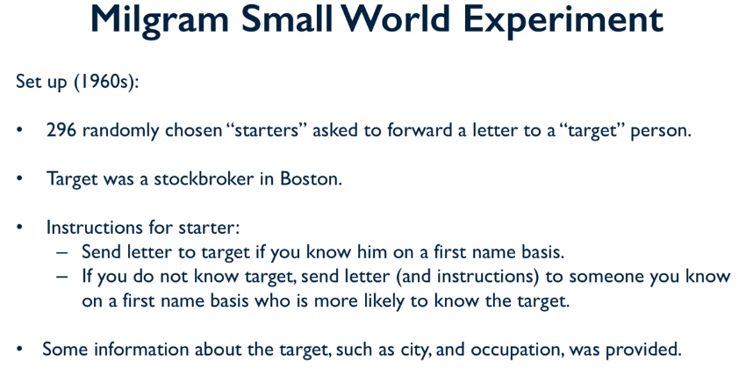

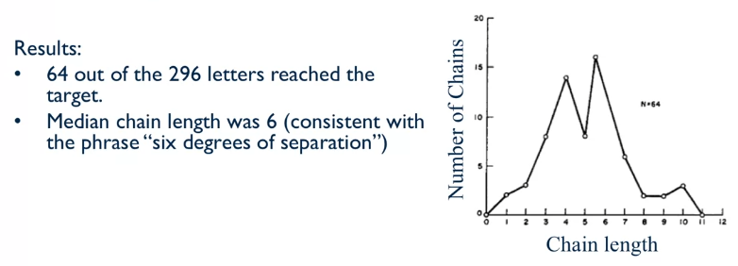

A relatively large percentage of people actually managed to reach the target. Considering that some people might not even bother to send the letters or pass the message on. The number of paths required to reach this person was relatively short.

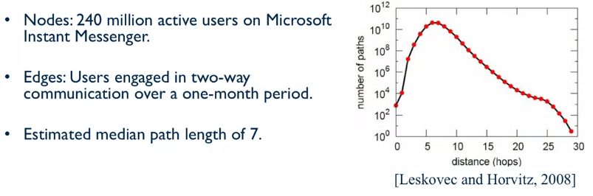

The median shortest path between a pair of randomly selected nodes is 7, which is very close to the value seen in the above example (6).

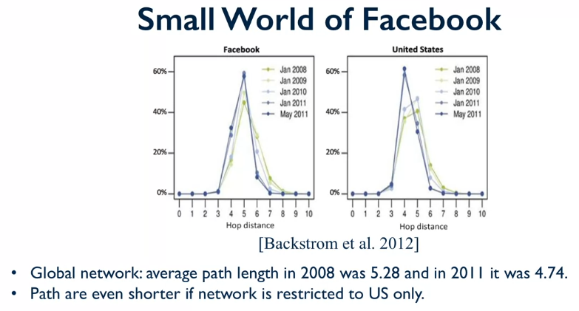

These shortest paths seem to be getting smaller as time goes on, and that the shortest path for smaller groups tends to be shorter.

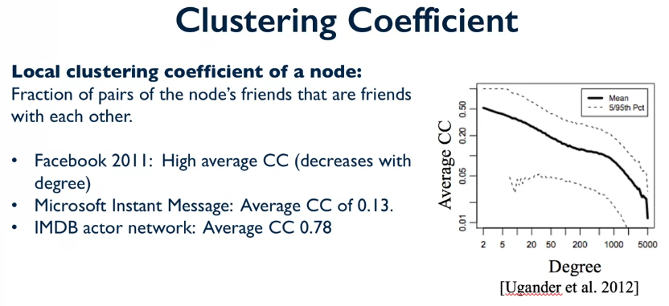

These clustering coefficients are pretty high.

Barabasi_alber_graph is the power law, preferential attachment model. The CC is low, but we get a good shortest path estimate.

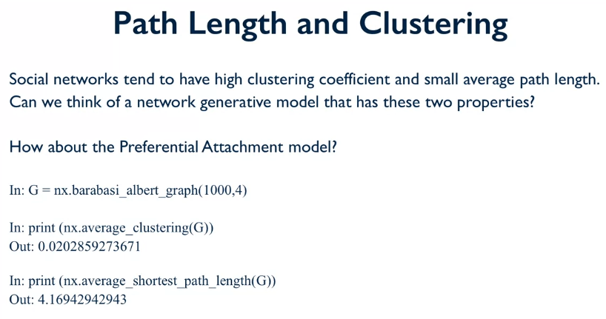

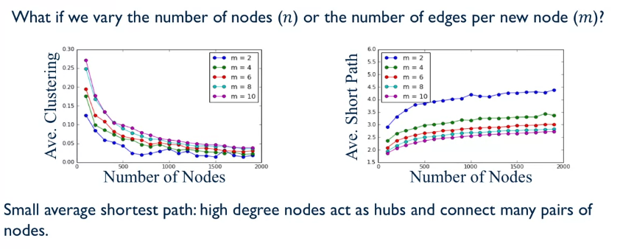

We can see that the shortest path remains relatively small, which is similar to the social network property. However, the average CC is much smaller, we saw that even with networks that had thousands of nodes that the average CC was much larger e.g. between 0.13 and 0.78! This makes sense as the preferential attachment model has no rule making it favour triangulation, so the average CC will be small.

The **Small World Model** creates networks that have both a large average CC and a small average shortest path.

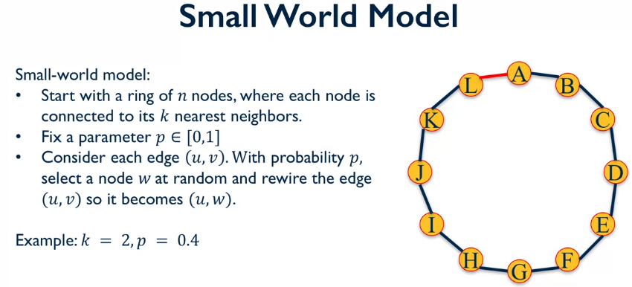

It’s worth noting that these values of k and p are not normal, k is normally much higher, and p is much smaller. From node A we walk around the circle and evaluate each edge and with probability p it might be rewired or not. After walking around the entire network, we end up with the following:

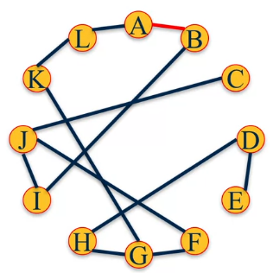

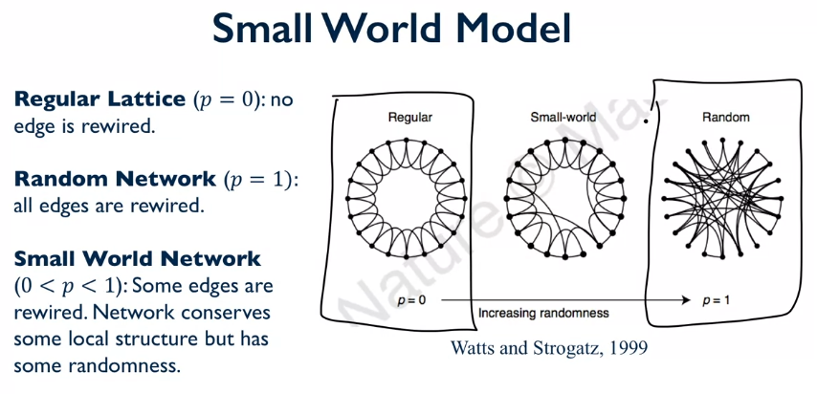

The model above has a value of k around 3-4. With very low p we can see that the network hardly changes from its original structure, this results in the average clustering coefficient to be large, but the average shortest path to be large. With a very high value of p we can see that the network is almost completely re-wired, and that the average CC is now smaller, but the average shortest path is smaller. This means that the **value p controls the trade-off between the average shortest path and average CC**.

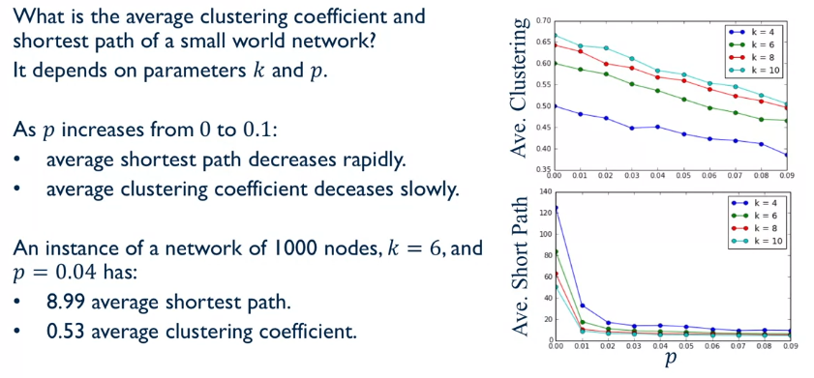

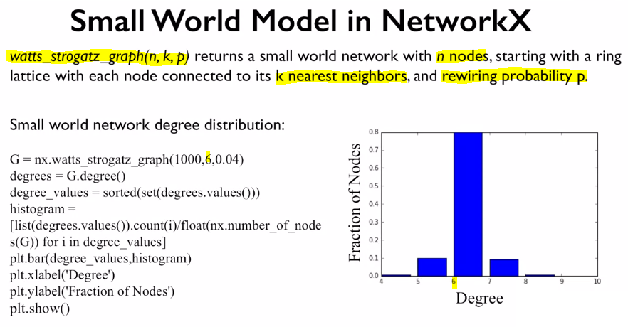

The above histogram makes sense as the rewiring probability is very low, so the majority of the edges will remain the same. This small world model does manage to achieve a good representation of the average CC and average shortest path, but it **doesn’t show the power law distribution** we’ve seen in other social networks.

